A Report

on

PriceScout
A Multivendor Price Comparison Engine

carried out as part of the course Project Based Learning- 4
Submitted by

Devanshu Sharma

23FE10CSE00274

VI Semester

in partial fulfilment for the award of the degree

of

BACHELOR OF TECHNOLOGY

In

Computer Science & Engineering



Department of Computer Science & Engineering,
School of Computer Science and Engineering,
Manipal University Jaipur,
Jan-May 2026

A Report

on

PriceScout
A Multivendor Price Comparison Engine

carried out as part of the course Project Based Learning-4
Submitted by

Devanshu Sharma

23FE10CSE00274

VI Semester

in partial fulfilment for the award of the degree

of

BACHELOR OF TECHNOLOGY

In

Computer Science & Engineering

Under the Guidance of :

Guide Name : Dr.Manu Shrivastava

Guide Signature(with date) : ………………………………………

Acknowledgement

This project would not have been completed without the help, support, comments, advice, cooperation and coordination of various people. However, it is impossible to thank everyone individually; I am hereby making a humble effort to thank some of them.

I acknowledge and express my deepest sense of gratitude to my internal supervisor Dr. Manu Shrivastava for his constant support, guidance, and continuous engagement. I highly appreciate his technical comments, suggestions, and criticism during the progress of this project titles “PriceScout : A Multivendot Price Comparison Engine”.

I owe my profound gratitude to Dr. Neha Chaudhary , Head, Department of CSE, for her valuable guidance and for facilitating me during my work. I am also very grateful to all the faculty members and staff for their precious support and cooperation during the development of this project.

Finally, I extend my heartfelt appreciation to my classmates for their help and encouragement.

Devanshu Sharma

23FE10CSE00274



Department of Computer Science and Engineering
School of Computer Science and Engineering

Date: _____________

CERTIFICATE

This is to certify that the project entitled “PriceScout : A Multivendor Price Comparison Engine" is a bonafide work carried out as PBL-4 End Term Assessment in partial fulfillment for the award of the degree of Bachelor of Technology in Computer Science and Engineering, by Devanshu Sharma bearing registration number 23FE10CSE00274, during the academic semester VI of year 2025-2026.

Place: Manipal University Jaipur, Jaipur

Name of the project guide: Dr. Manu Shrivastava

Signature of the project guide: ______________________

PROJECT PROGRESS REPORT

Abstract
PriceScout is a web-based price comparison system designed to help users find the best deals across multiple e-commerce platforms. The system fetches product data from different vendor APIs such as ElectroStore, QuickShop, and GadgetHub, compares prices, and displays the most economical option to the user. The project simulates real-world e-commerce scenarios using mock APIs and demonstrates concepts like distributed systems, REST API communication, and data integration. The system also stores search history for future reference. This project provides a practical understanding of full-stack development and system design.

1.Introduction
With the rapid growth of e-commerce platforms, users often find it difficult to compare prices across multiple websites efficiently. Each platform offers different pricing, discounts, and offers, making manual comparison time-consuming and inconvenient. PriceScout addresses this problem by providing a centralized platform that aggregates product data from multiple vendors and presents a comparative analysis. The system improves user convenience and ensures better decision-making.
1.1Objective of the project
• To develop a system that compares product prices across multiple vendors
• To provide users with the best available deal
• To simulate real-world e-commerce API integration
• To build a scalable and user-friendly web application
1.2Brief description of the project
PriceScout is a Flask-based web application that communicates with multiple vendor services using REST APIs. When a user searches for a product, the system sends requests to different vendor servers, collects product data, merges the results, and identifies the best price. The results are displayed on a web interface, and search data is optionally stored in a database.
1.3Technology used
- Python (Flask)
- HTML, CSS, JavaScript
- REST APIs
- MySQL (optional)
- Git & GitHub

1.4.1 H / W Requirement
• System with minimum 4GB RAM
• Internet connectivity
• Processor: Intel i3 or above

1.4.2 Software Requirement
• Python 3.x
• Flask Framework
• MySQL (optional)
• Web Browser (Chrome/Edge)
• VS Code

2. Design Description
The system follows a multi-tier architecture:
- Frontend: User interface for search and display
- Backend: Flask server handling logic
- Vendor APIs: Simulated external services
- Database: Stores search history and product data

2.1 Flow Chart
2.2 Data Flow Diagrams(DFDs)
2.3 Entity Relatoinship Diagram(E-R Diagram)

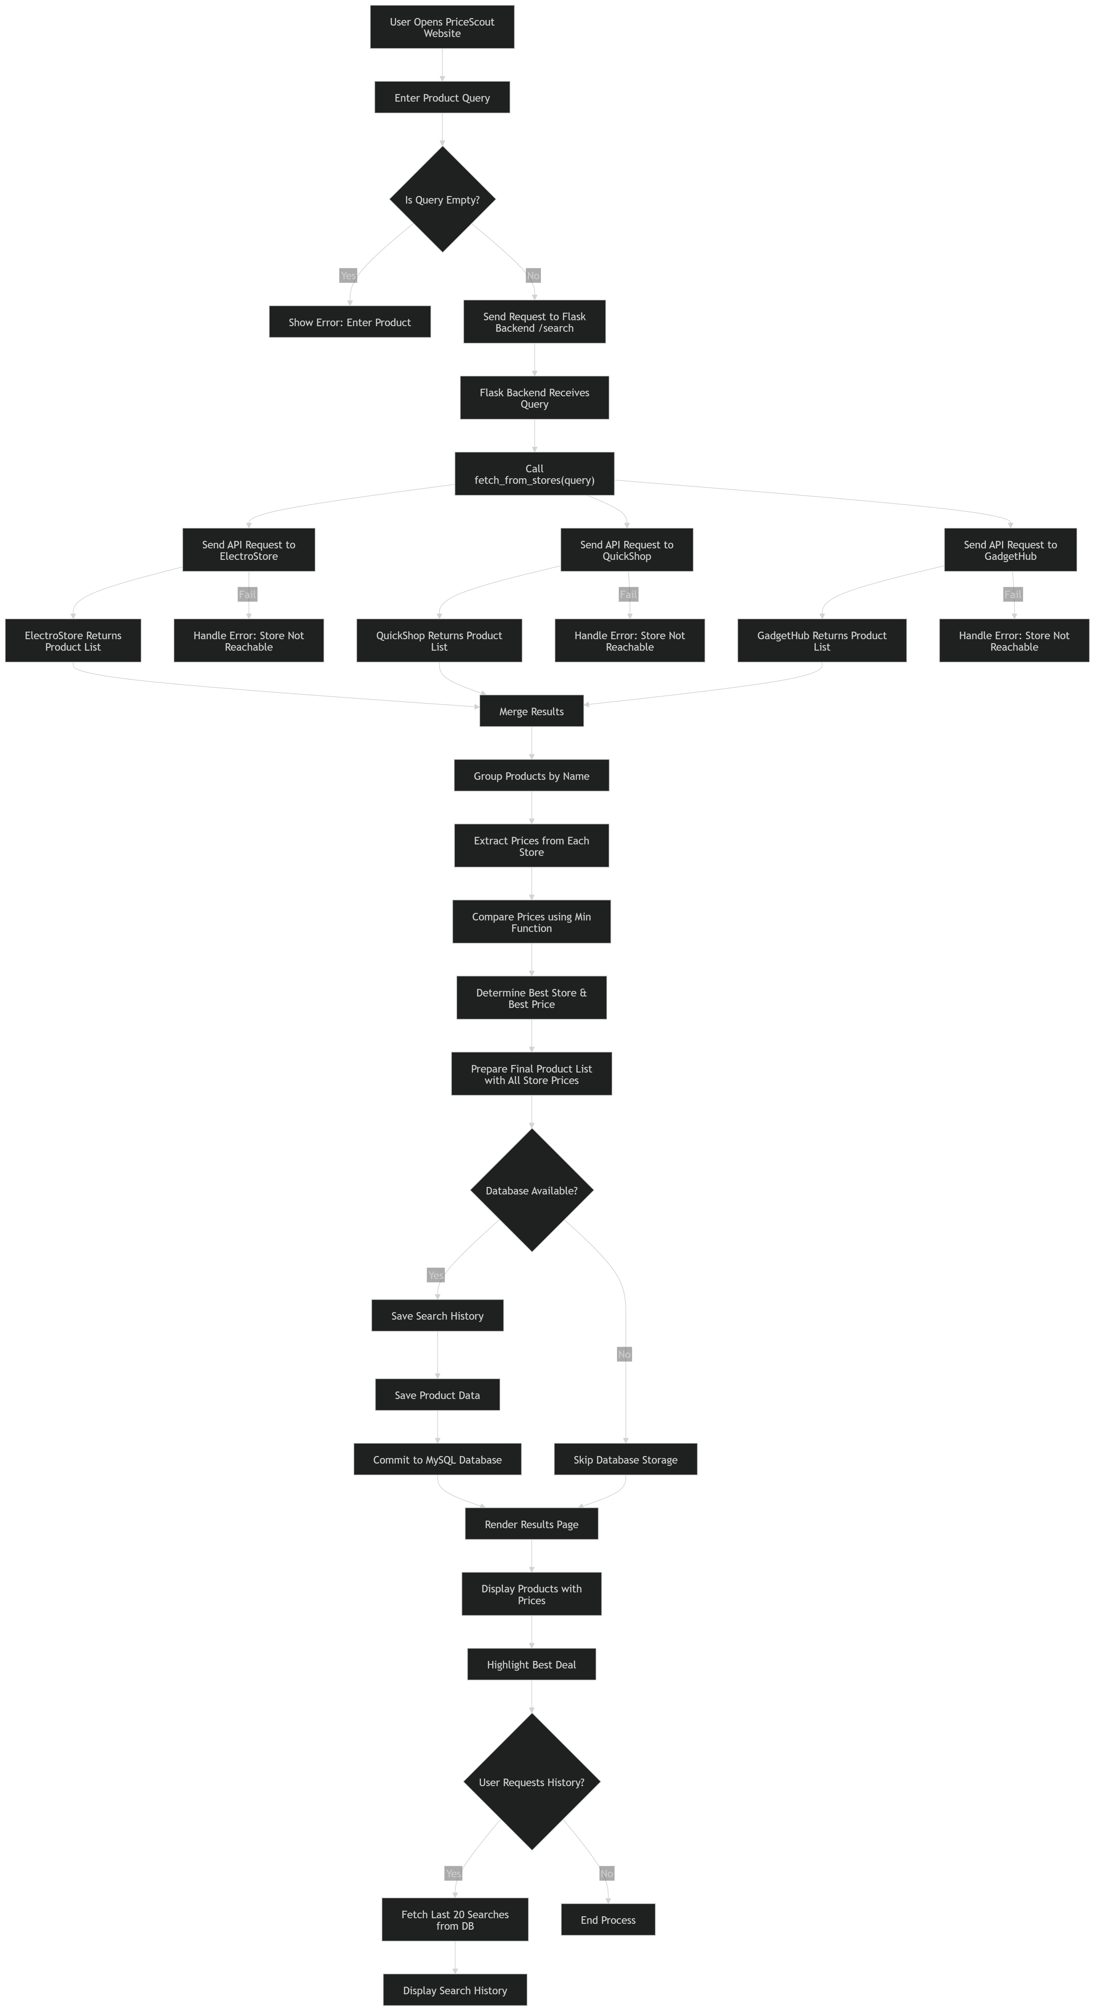
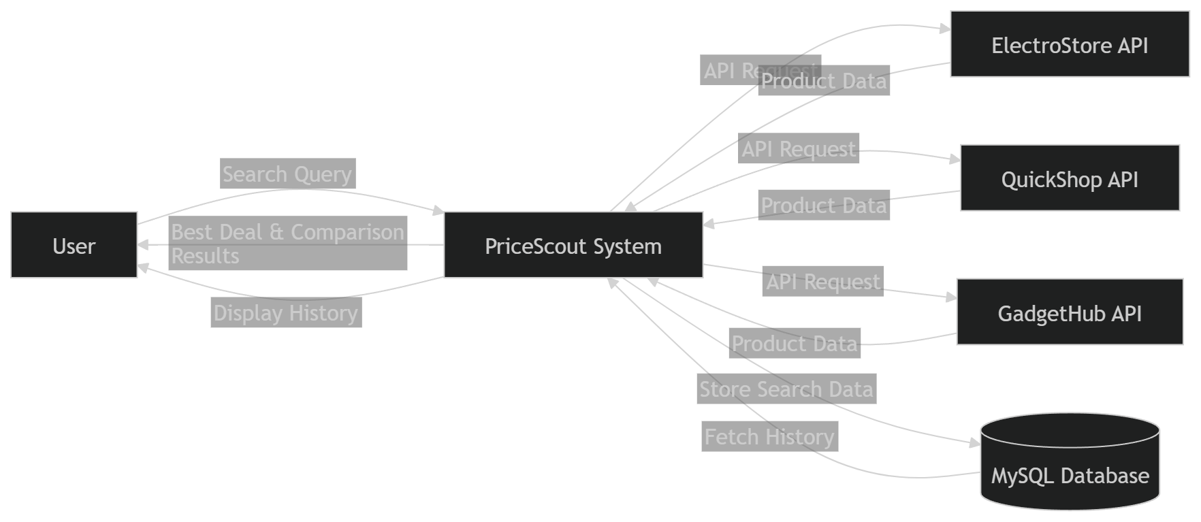
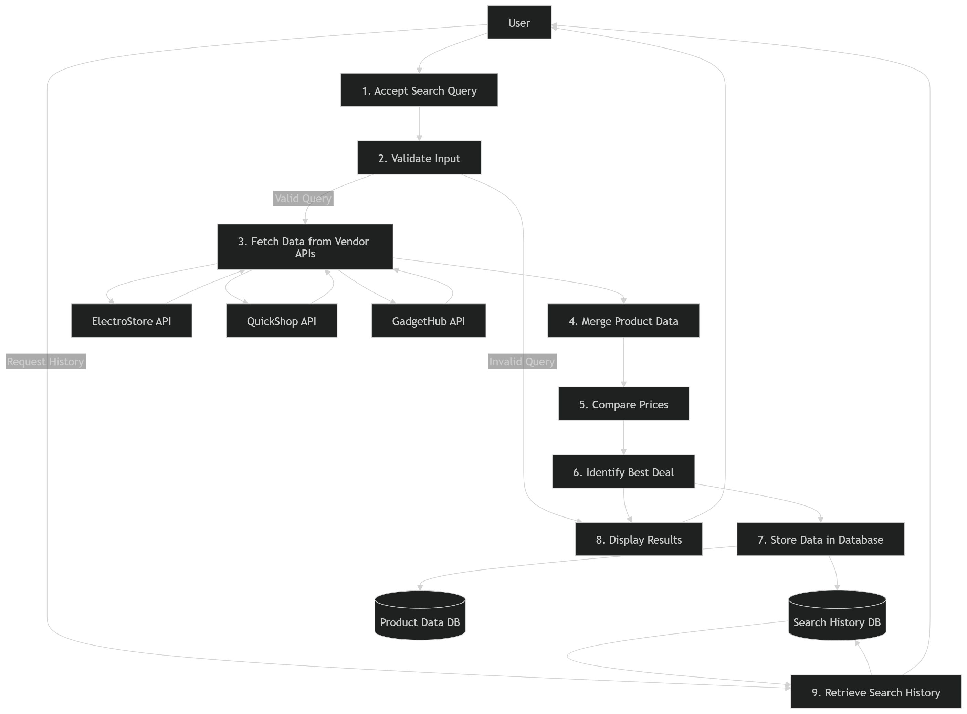

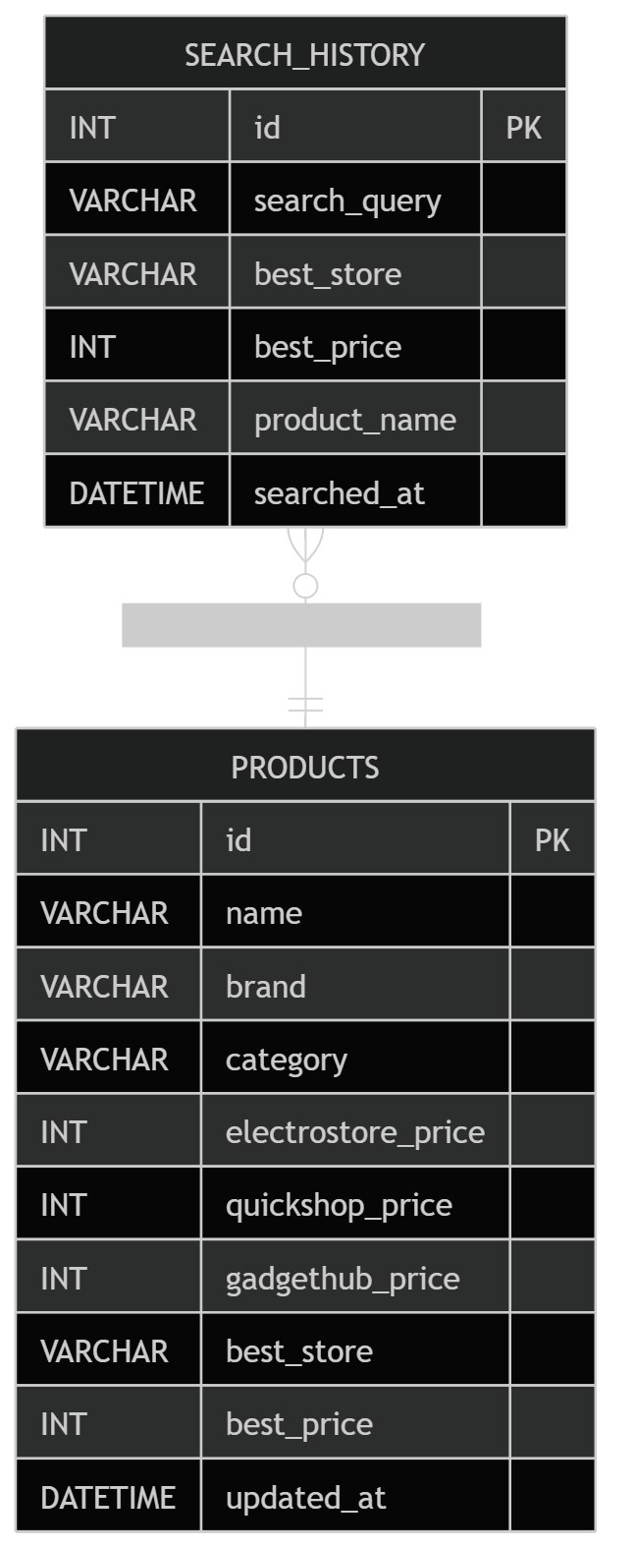
3. Project Description
The system works by sending search queries to multiple vendor APIs. Each vendor returns product details including price, rating, and specifications. The backend merges these responses and compares prices using a minimum value selection algorithm. The best deal is identified and presented to the user. The system ensures modularity by separating vendor services from the main application.

3.1 Data Base
Database Name: pricescout
Tables:
- search_history
- products

3.1.1 Table Description
search_history
- id
- search_query
- best_store
- best_price
- product_name
- searched_at
products
- id
- name
- brand
- category
- store prices
- best_store
- best_price

4. Input/Output Form Design
Input:
- Product search query
Output:
- List of products from multiple vendors
- Price comparison
- Best deal highlighted

5. Testing & Tools used
- Manual Testing
- API Testing using browser
- Debugging using Flask logs

6. Implementation & Maintenance
The system is implemented using Flask for backend and HTML/CSS for frontend. Vendor services are deployed locally on different ports and accessed via REST APIs. The application is tested in a local environment.

7. Conclusion and Future Work
The system is implemented using Flask for backend and HTML/CSS for frontend. Vendor services are deployed locally on different ports and accessed via REST APIs. The application is tested in a local environment.

8. Outcome
A working prototype of the PriceScout system has been successfully developed. The system performs real-time price comparison using multiple vendor APIs. The project has been partially deployed in a local environment and demonstrates practical implementation of distributed systems.

9. Bibliography
- Spring Boot Documentation
- Flask Documentation
- REST API Design – restfulapi.net
- GitHub Documentation

